**PERSONALISED LEARNING MANAGEMENT SYSTEM**

Project submitted to

SRM University – AP, Andhra Pradesh

For the course project of

**CSE305L Software Engineering Lab**

Submitted by

Ananya Yerukola (AP21110010602)

Jupalli Ajith (AP21110010624)

Namburi Anvitha Tulasi (AP21110010633)

Muppavarapu Harshavardhini (AP21110010637)



Under the guidance of

Dr. Amit Kumar Singh

**TABLE OF CONTENTS:**

1. ABSTRACT

2. INTRODUCTION

3. EXISTING SYSTEM/LITERATURE REVIEW

4. SYSTEM REQUIREMENTS

5. PROPOSED SYSTEM

6. CONCLUSION

**ABSTRACT**

In the digital era, the landscape of education has witnessed a transformative shift towards online learning platforms. This project aims to explore and enhance the accessibility of e-learning environments for diverse learners. With a focus on inclusivity, the project will investigate various aspects such as user interface design, content presentation, and interactive features to accommodate learners with different abilities and learning styles.

Through extensive research and user feedback analysis, the project will identify barriers that hinder accessibility in existing e-learning platforms. Developing feedback mechanisms that are adaptive and inclusive, allowing learners to demonstrate their understanding through varied modalities.

Furthermore, the project will prioritize scalability and compatibility across different devices and platforms to ensure widespread accessibility. Collaboration with educators, technologists, and accessibility experts will be integral to the iterative development process, fostering a holistic approach towards creating inclusive e-learning environments.

Key objectives include: Designing intuitive user interfaces that are navigable and customizable to accommodate diverse learner preferences.

**INTRODUCTION**

In today's educational landscape, personalized learning has emerged as a transformative approach to cater to diverse learner needs and maximize learning outcomes. Personalized Learning Management Systems (PLMS) represent a technological solution designed to adapt to individual learners, providing tailored educational experiences that align with their unique preferences, abilities, and learning goals.

Traditional one-size-fits-all educational models often struggle to accommodate the varied learning styles and paces of individual students. Personalized LMS platforms leverage technology to address this challenge by incorporating adaptive learning algorithms, data analytics, and interactive features that enhance learner engagement and effectiveness.

ELearning is an alternative to a traditional classroom learning experience and is often referred to as “online learning,” “remote learning,” “virtual learning,” “mobile learning,” “digital learning,” or “distance education.

The purpose of E-Learning Management Systems (LMS) is to provide a centralized and accessible platform for delivering educational content, fostering collaboration, and streamlining administrative tasks. By leveraging technology, LMSs enhance the teaching and learning experience by offering flexibility in accessing course materials, facilitating interaction among learners and instructors, and supporting personalized learning pathways. Additionally, LMSs optimize administrative processes such as enrollment management, grading, and reporting, thereby increasing efficiency and scalability while reducing costs associated with traditional classroom-based instruction. Overall, the primary aim of E-Learning Management Systems is to empower educators and learners to engage effectively in the learning process, regardless of time, location, or individual learning preferences.

**LITERATURE REVIEW**

A review of the literature on Personalised Learning Management Systems (PLMS) highlights research on usability, adoption, and effectiveness. Studies emphasize user-centred design, factors influencing adoption, and mixed findings regarding the impact on teaching and learning outcomes. Overall, the literature underscores the importance of considering usability, adoption factors, and pedagogical approaches to maximize the benefits of LMS in diverse educational settings.

Personalised Learning Management Systems (PLMS) commonly integrate essential functions to support efficient and effective online education. These functions include content management for organizing and delivering educational materials, course administration for user management and enrolment, communication and collaboration tools to facilitate interaction among learners and instructors and feedback mechanisms for evaluating learning progress, for monitoring learner performance, and increasingly, learning analytics capabilities to glean insights from learner data. With mobile compatibility becoming increasingly important, many LMS platforms also offer mobile-responsive designs or dedicated apps, ensuring seamless access to course content and activities across devices. These integrated functions collectively provide a robust framework for educators to create engaging and interactive learning experiences while effectively managing the online learning environment.

**SYSTEM REQUIREMENTS**

**Operating System:**

The project can run on various operating systems including Windows, macOS, Linux, etc.

Ensure compatibility of the web server, PHP, and database server with the chosen operating system.

**Client-Side Requirements:**

Modern web browser with support for HTML5, CSS3, and JavaScript.

Responsive design for compatibility with various devices including desktops, laptops, tablets, and smart phones.

**Security:**

Implement secure coding practices to prevent common web vulnerabilities such as SQL injection, cross-site scripting (XSS), cross-site request forgery (CSRF), etc. Use HTTPS to encrypt data transmitted between the client and server to ensure data privacy and security.

**Response Time:**

The system should respond to user interactions within 2 seconds under normal load conditions.

**Throughput:**

The LMS should support concurrent access by at least 1000 users without a significant degradation in performance.

**Availability:**

The system should be available for use at least 99.9% of the time, excluding scheduled maintenance windows.

**Reliability:**

The LMS should be capable of handling large volumes of concurrent user interactions without experiencing system crashes or data corruption.

**Authentication:**

Implement secure authentication mechanisms, such as username and password, multi-factor authentication (MFA) by sending an email for verification.

**Session Management:**

Implement secure session management mechanisms, such as session timeoutsto prevent unauthorized access to user accounts.

**Performance:**

The software should respond promptly to user interactions and process tasks efficiently within acceptable timeframes.

**Maintainability:**

The software should be designed and implemented in a modular and well-structured manner, with clear separation of concerns

**Scalability:**

Design the system to handle a large number of users and courses efficiently.

**PROPOSED SYSTEM**

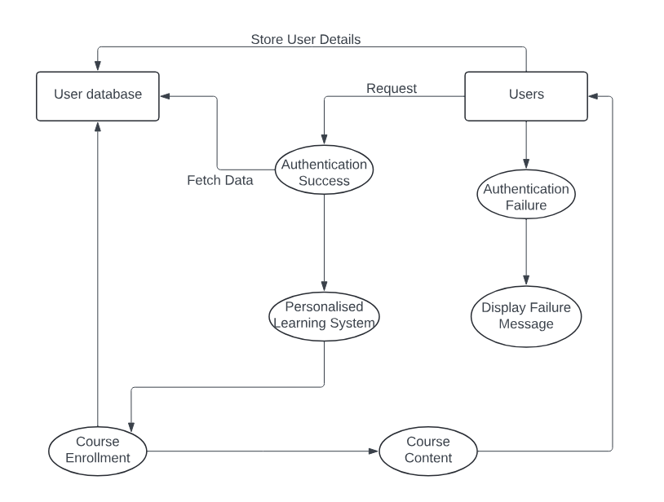

**COCOMO MODEL**

**MODE PROJECT**: Organic

**SIZE:** 7.154 KLOC

**NATURE AND PROJECT**: Small size project, experienced developers in the familiar environment.

**INNOVATION:** Little

**DEADLINE:** Not Tight

**BASIC:**

Total number of lines in our code = 7154

Effort (E) = 2.4*[(7.154)]^1.05 = 18.949

Tdev (D) = 2.5(18.944)^0.38 = 7.645

Staff (SS) = E/D = 18.944/7.6456 = 2.4779

Productivity (P)=7.154/18.944 = 0.3776

**INERMEDIATE:**

RELY 🡪 0.88

DATA 🡪 1

CPLX 🡪 0.85

TIME 🡪 1

STOR 🡪 1

VIRT 🡪 0.87

TURN 🡪 1

ACAP 🡪 1

AEXP 🡪 1.13

PCAP 🡪 1

VEXP 🡪 1.1

LEXP 🡪 1

MODP 🡪 1

TOOL 🡪 1.1

SCED 🡪 1.08

EAF = 0.9609

E=24.271

D=8.400

SS=2.8894

P=0.2947

**Detailed COCOMO**

E=24.271

D=8.400

SS=2.8894

P=0.2847

EP= $pE

= 0.06*24.271 = 1.4562 (plan and require)

= 0.16*24.271 = 3.8832(system design)

= 0.26*24.271= 6.3102(Detailed design)

= 0.42*24.271= 10.1934(Module cost and test)

= 0.16*24.271=3.8832(Integration and test)

Dp = tpD

Plan and require 🡪 0.1*8.4=0.84

System design 🡪 0.9*8.4=1.596

Detailed design 🡪 2.016

Module cost and test 🡪 3.276

Integration and test 🡪 1.512

Total Cost (Basic) = 358.9612

(Intermediate) = 589.0804

**RESULTS**

**Login page:**

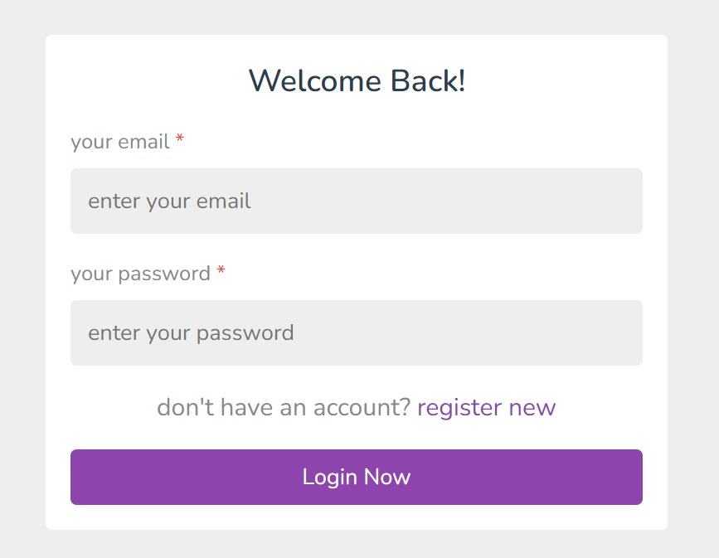

**Admin Dashboard:**

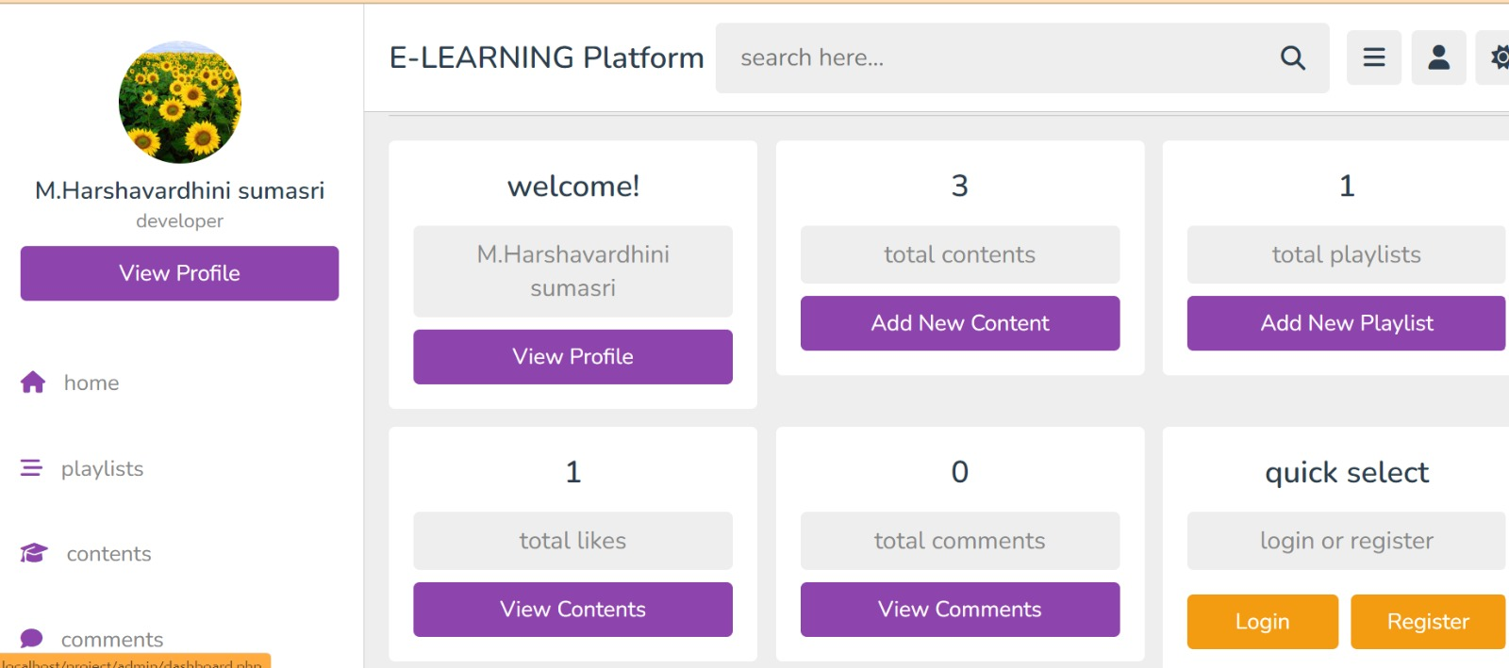

**Added playlists:**

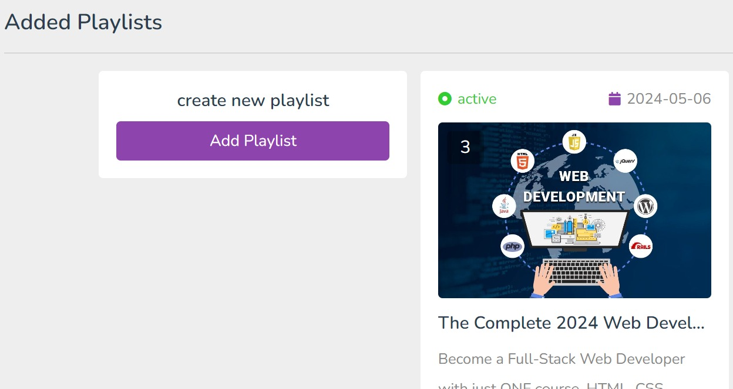

**Contents posted by the admin:**

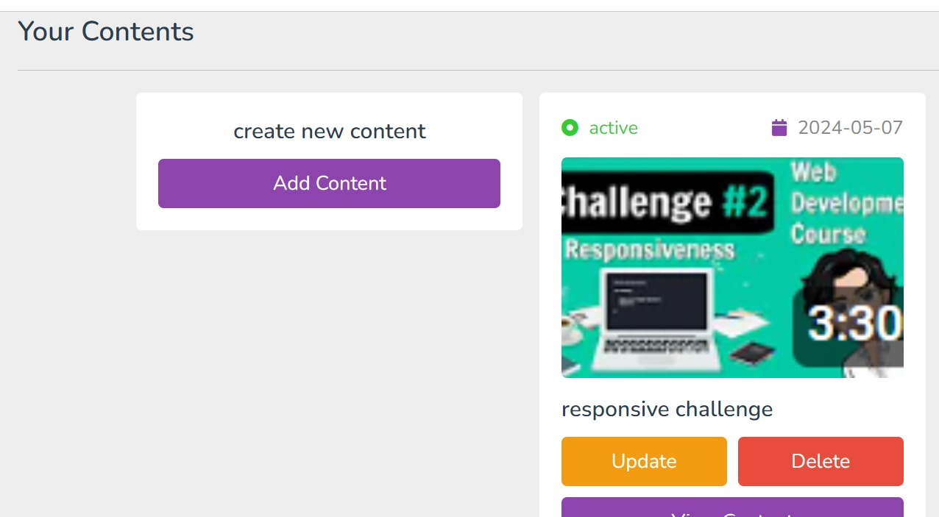

**Comments that the admin content get:**

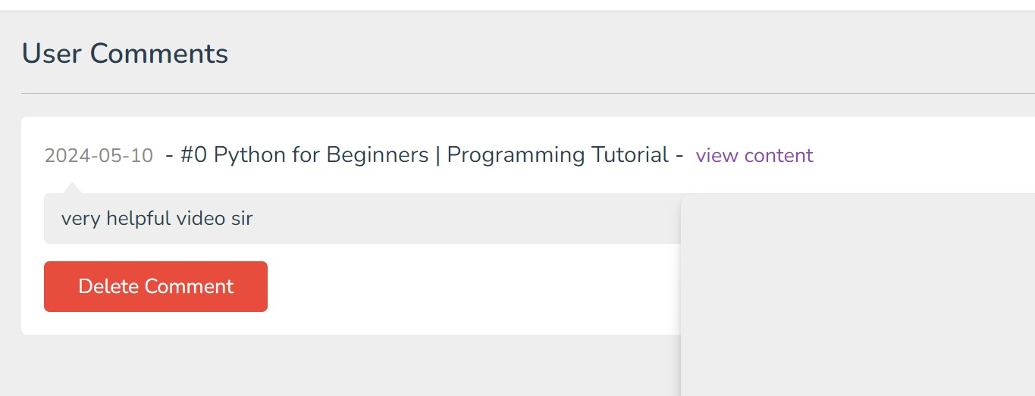

**Sign up page for new users:**

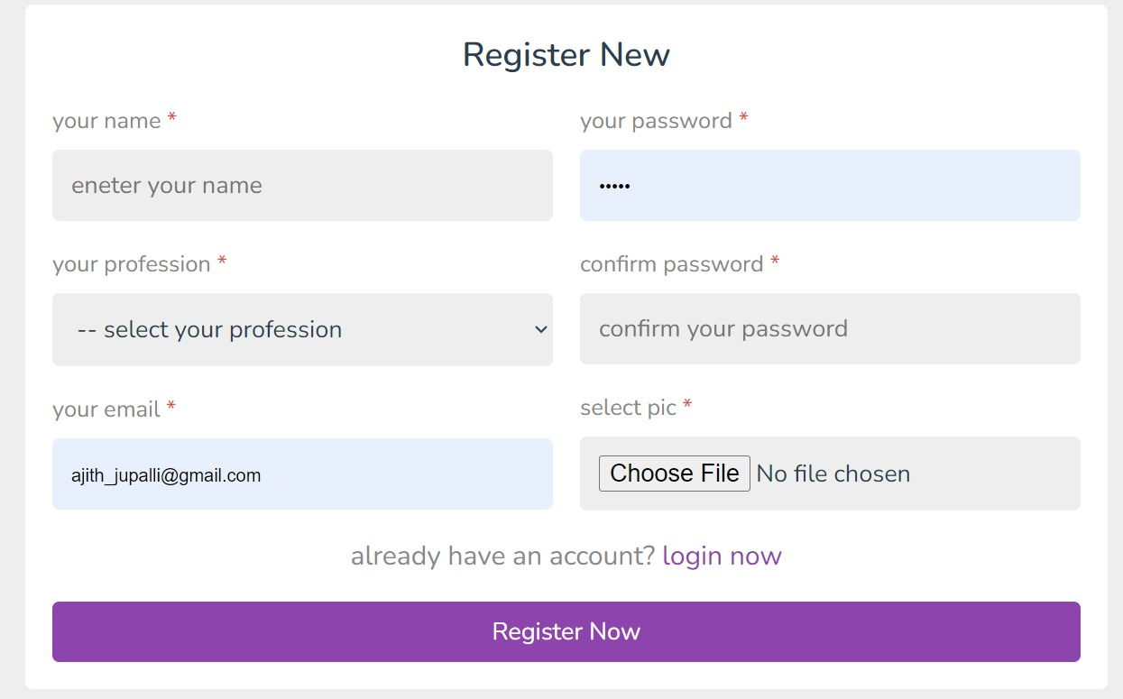

**Student Home Page:**

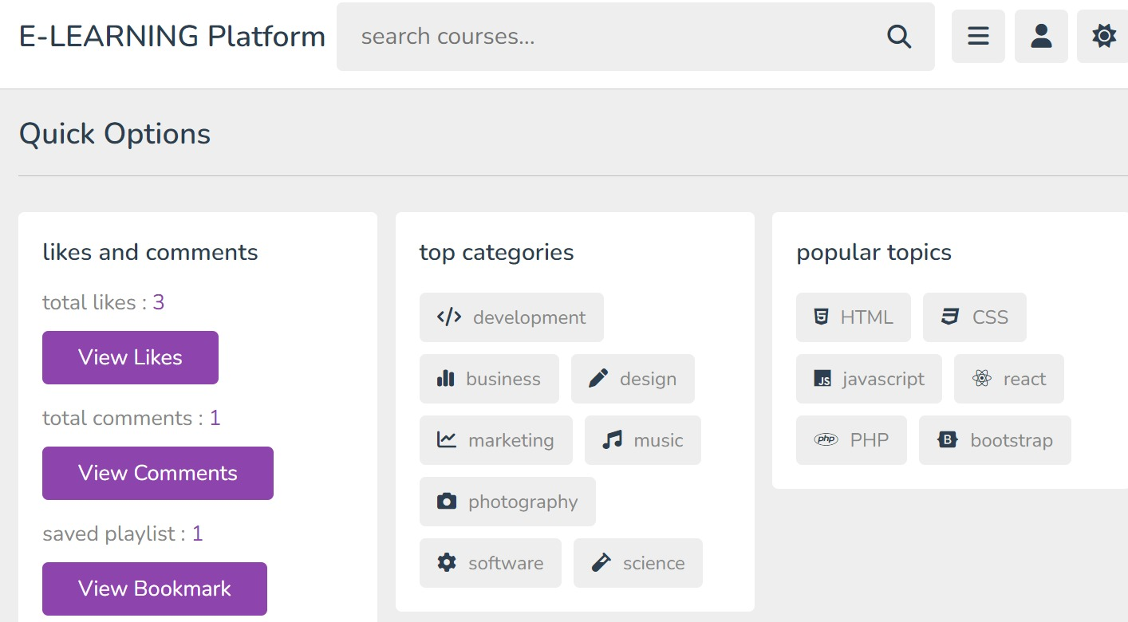

**Student Profile:**

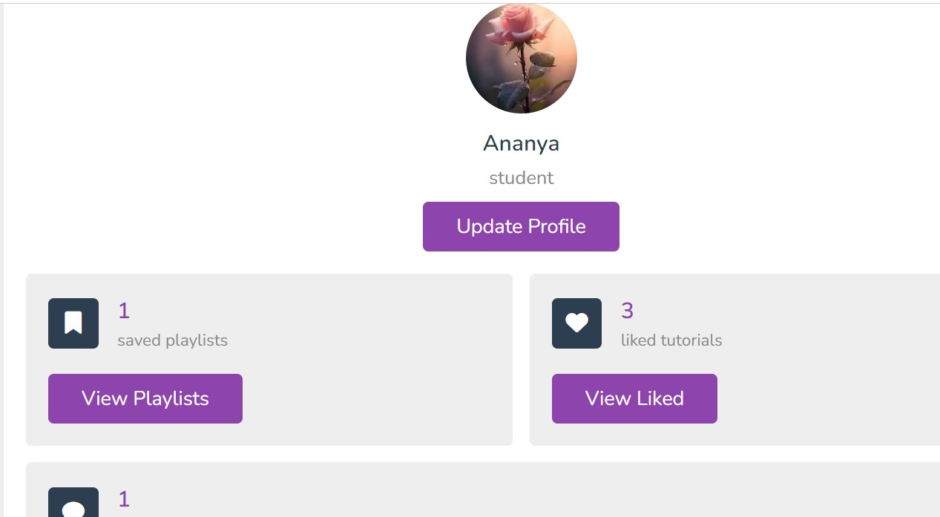

**Available Courses:**

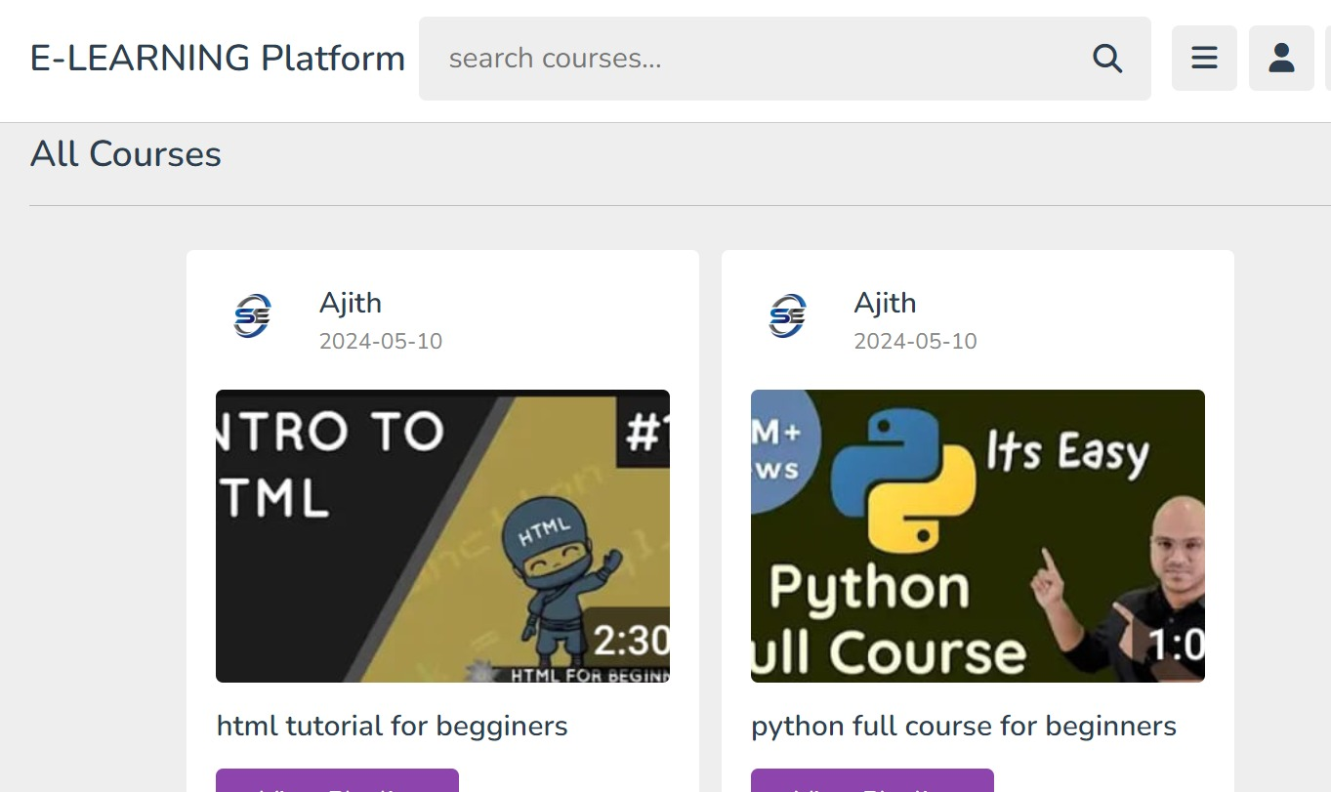

**Tutors:**

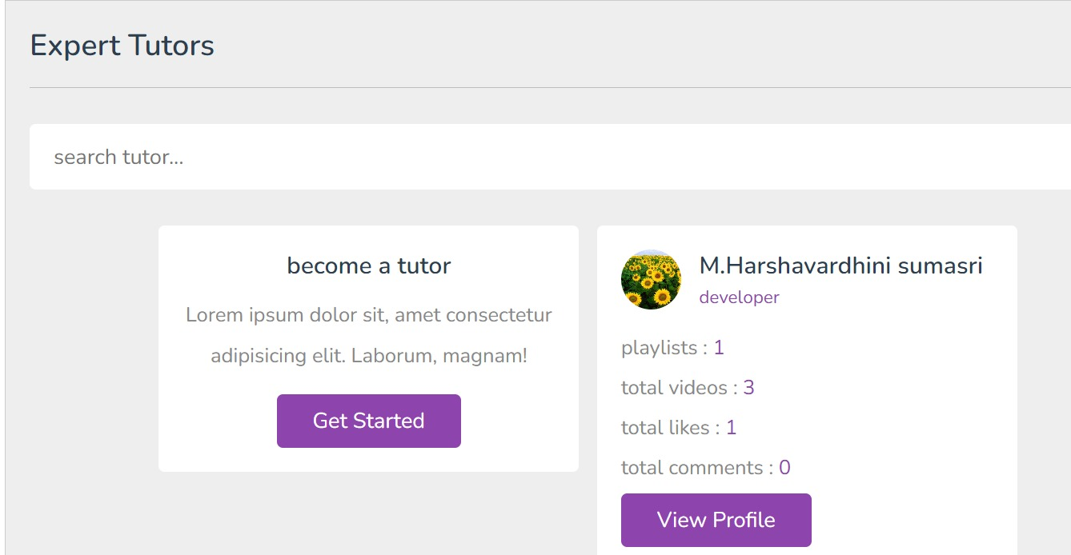

**CONCLUSION**

In conclusion, Personalised Learning Management Systems (PLMS) represent a pivotal tool in modern education, offering a comprehensive suite of integrated functions to facilitate efficient and effective online learning experiences. By centralizing content management, course administration, communication, assessment, and analytics within a single platform, LMS empower educators to deliver engaging and interactive learning materials while enabling learners to access, collaborate, and progress through their courses with ease. As the demand for flexible and accessible education continues to grow, the importance of LMS in supporting remote, blended, and lifelong learning initiatives cannot be overstated. Moving forward, continued innovation and integration of emerging technologies will further enhance the capabilities of LMS, ensuring that they remain indispensable tools for educators and learners alike in the ever-evolving landscape of education.